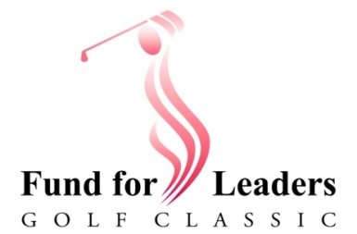
2022 Fund for Leaders Golf Classic
Golfer Registration Form
Monday, November 14 – 8:00 AM Shotgun Start
Arrowhead Golf Club - 19888 N 73rd Ave, Glendale, AZ 85308
7:00 AM Doors open for Check in and Warm Up
Select group or single player registration option: o Captain with a group of ___ o Single Golfer(s)
- $150 cost of registration per player (same as last year!) includes: 18 holes, lunch, automatic entry in drawings for a free golf round, and a $27.48 charitable gift to the ELCA Fund for Leaders in Mission.
- Give more if you can. See below for easy ways to increase your support of the Fund.
- Mulligans and raffle tickets are sold separately the day of the event and are not tax-deductible.
PLEASE PRINT - HELP THE REGISTRAR
GOLFER #1 (Captain’s name if this is a group) |  | City | State | Zip
Phone | Email Address | Congregation (if Applicable)

GOLFER #2 | Street Address | City | State | Zip
Phone | Email Address | Congregation (if Applicable)

GOLFER #3 | Street Address | City | State | Zip
Phone | Email Address | Congregation (if Applicable)

GOLFER #4 | Street Address | City | State | Zip
Phone | Email Address | Congregation (if Applicable)

Help meet our $20,000 match challenge! Increase Player/Team giving one or more ways:
__ Premier Sponsor ($1000 includes 4 golfers)
__ Tournament Sponsor ($500 includes 2 golfers)
__ Hole Sponsor ($250 includes 1 golfer)
__ Supporter (registration fee plus any amount under $250)

PAYMENT SUMMARY |  |  | Names of additional lunch guests
___ Golfer(s) @ $150 EACH | $
___ Sponsor(s) @ $1000, $500, $250 | $
___ Supporter(s) @ $151 - $249 | $
Additional lunch guests @ $40 EA | $ |  | 1. Please make checks payable to:  Grand Canyon Synod / Fund for Leaders  2. Mail to: Fund for Leaders Golf  986 N Maverick Trail, Dewey AZ 86327
___ CHECK(S) enclosed total F | $

