An Article for Church Newsletters:
- Publicity for the Grand Canyon Synod Fund for Leaders Scholarship
- An Appeal for Golfers and Donors

Somewhere along the way, a pastor came alongside.
Accompanied you through a baptism, a wedding, a medical procedure, a burial.
Prayed for you through good times and bad.
Called you by name in rituals of remembrance.

In gratitude for the men and women who proclaim the Gospel throughout the span of our lives, the annual appeal to support future church leaders is underway. The appeal is twofold: First, to invite golfers to participate in the Golf Classic. Second, to invite anyone with a passion for the future of the church to donate to the Fund for Leaders.

Here in Arizona, our annual Golf Classic raises funds for seminarians whose call to ministry has come out of local congregations. By making seminary more affordable, our gifts empower these emerging leaders to serve where there is need and as the Spirit leads. Our gifts help equip them to lead congregations through tough times while also inspiring us all to envision new ways of Being Church.

Please support this year’s Fund for Leaders appeal if you:
- wonder what you can do about the ongoing shortage of pastors and deacons.
- think the Holy Spirit, not overwhelming debt, should be the primary factor in candidacy decisions.
- want the church to thrive and know healthy leaders make all the difference in the world.

This year’s goals:
- find 144 golfers for the Golf Classic at Arrowhead Country Club on November 14.
- raise $20,000 in donations (if we meet this goal, one donor has promised to match it)!

For more information on registering for the Golf Classic and/or donating to the synod’s Fund for Leaders, contact Pr. Kirk Anderson (retired) at 928-420-1422 or at kirkemm@gmail.com.

Graphics for Congregational Use:

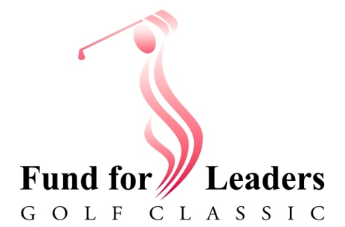

Excerpts of Gratitude from Recipients of Grand Canyon Synod Scholarship Fund:

